Homonyms (True)

🔹 What Are Homonyms (True)
# Source: AI Source: Provided by: [Data Path: Persons Table -> ID Column: 1, Name_En Column: Motasem Essam] -> From: [Chatgpt (GPT-4-turbo)] on [8/1/2025]
Homonyms (true) are words that are both:
- Pronounced the same, and
- Spelled the same,
but have completely different and unrelated meanings.
These are a subtype of homophones (since they sound the same), but also fall under homographs (since they are spelled the same).
They are “true” in that they satisfy both conditions — sound and spelling match, but meanings differ entirely.

🧱 Key Features of True Homonyms (as Homophones)
# Source: AI Source: Provided by: [Data Path: Persons Table -> ID Column: 1, Name_En Column: Motasem Essam] -> From: [Chatgpt (GPT-4-turbo)] on [8/1/2025]
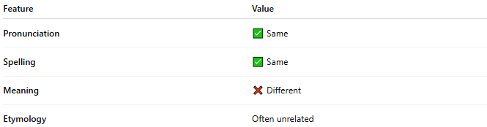
Feature | Value
Pronunciation | ✅ Same
Spelling | ✅ Same
Meaning | ❌ Different
Etymology | Often unrelated

📝 Examples of Homonyms (True)
# Source: AI Source: Provided by: [Data Path: Persons Table -> ID Column: 1, Name_En Column: Motasem Essam] -> From: [Chatgpt (GPT-4-turbo)] on [8/1/2025]
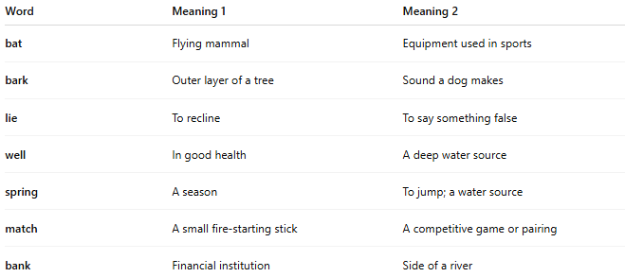
Word | Meaning 1 | Meaning 2
bat | Flying mammal | Equipment used in sports
bark | Outer layer of a tree | Sound a dog makes
lie | To recline | To say something false
well | In good health | A deep water source
spring | A season | To jump; a water source
match | A small fire-starting stick | A competitive game or pairing
bank | Financial institution | Side of a river

🎨 In Poetry and Language
# Source: AI Source: Provided by: [Data Path: Persons Table -> ID Column: 1, Name_En Column: Motasem Essam] -> From: [Chatgpt (GPT-4-turbo)] on [8/1/2025]
True homonyms, when used as homophones, create:
- Puns
The bank was robbed near the bank of the river.
- Ambiguity and clever double meanings
- Identical rhymes (since the words are identical in sound and form)

🧭 Comparison with Other Homophones
# Source: AI Source: Provided by: [Data Path: Persons Table -> ID Column: 1, Name_En Column: Motasem Essam] -> From: [Chatgpt (GPT-4-turbo)] on [8/1/2025]
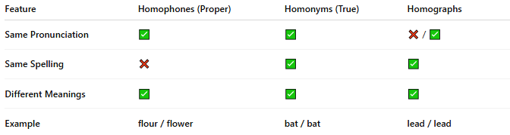
Feature | Homophones (Proper) | Homonyms (True) | Homographs
Same Pronunciation | ✅ | ✅ | ❌ / ✅
Same Spelling | ❌ | ✅ | ✅
Different Meanings | ✅ | ✅ | ✅
Example | flour / flower | bat / bat | lead / lead

⚠️ Key Point
# Source: AI Source: Provided by: [Data Path: Persons Table -> ID Column: 1, Name_En Column: Motasem Essam] -> From: [Chatgpt (GPT-4-turbo)] on [8/1/2025]
Every true homonym is a homophone, but not every homophone is a true homonym.
- Homophones (proper) differ in spelling
- True homonyms share both spelling and sound but differ in meaning

